
A 10
SET NO : 1

Sreenidhi Institute of Science & Technology
(An Autonomous Institution)
Code No: 101EE41

B. TECH. I – Year II – Semester Examinations, July/Aug, 2011 (Regular)
BASIC ELECTRICAL ENGINEERING (Common to ME, CSE, IT & BT)

Time: 3 Hours Max. Marks : 70

Note : No additional answer sheets will be provided.

Part-A (Objective Type)
Max.Marks:20

Answer all QUESTIONS.

1. Explain Faraday's Laws of Electro Magnetic Induction?
2. What is the equivalent resistance between A and D.
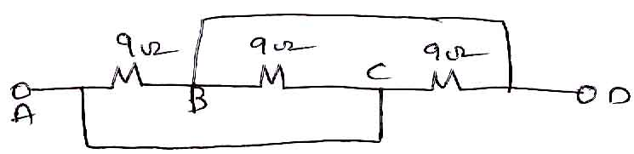
3. If v(t) = 20 sin (50t+25⁰) find amplitude, phase, period and frequency?
4. Define form factor and peak factor.
5. Draw the circuit of a dc series and shunt motor.
6. Explain about losses in a transformer in brief?
7. A 6600/440V, 1-φ 600kvA transformer has 1200 primary turns determine
i) transformation ratio ii) secondary turns.
8. Write the relationship between line and phase quantities, in star corrected networks?
9. A 4- pole 3-φ induction motor runs at 1740 rpm calculate % slip if the supply frequency is 60 Hz?
10. Explain briefly indicating and recording instruments.
Part – B
Max. Marks: 50
ANSWER ANY FIVE QUESTIONS.
EACH QUESTION CARRIES 10 MARKS.

1. a) Obtain the equivalent circuit using source transformation [ 5 ]
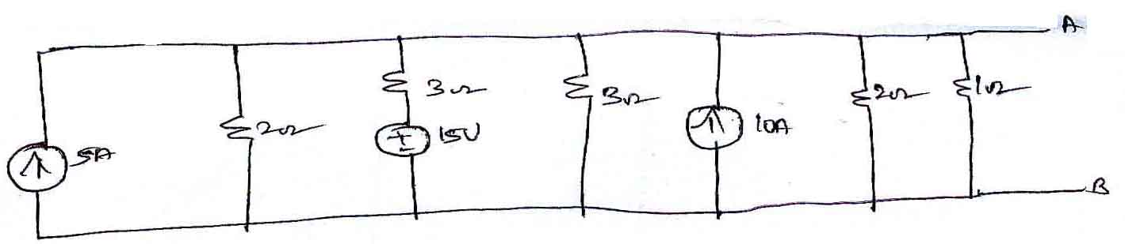

b) Calculate the current supplied by the voltage source. [ 5 ]
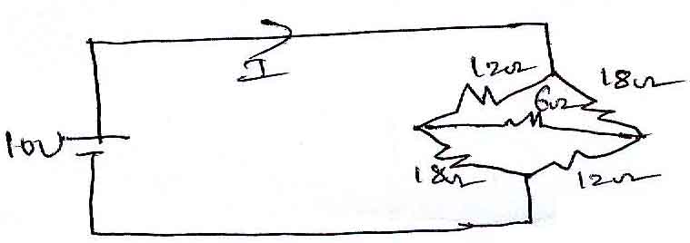

2. a) State and explain clearly about Kirchoff's laws. [ 5 ]

b) Solve for voltage v in figure below by using super position theorem? [ 5 ]
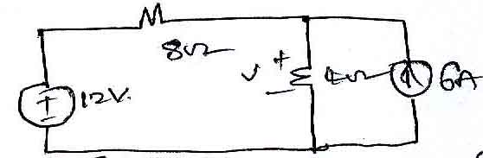
3. a) Obtain the phase relation between current & voltage when a resistor is connected across sinusoidal voltage. [ 5 ]

b) Calculate rms and average values of a full wave rectified sine wave whose maximum value is 50V. [ 5 ]
4. a) How DC generators are classified? [ 5 ]

b) 4-pole, 220v shunt motor has 540 lap wound condoctors, it takes 40 A from the supply mains and develops - output power of 6 kw. The field current is 1A. The armature resistance is 0.1Ω, and flux per pole is 20mwb. Calculate i) speed ii) Back emf iii) armature current? [ 5 ]

5. a) Define efficiency of a transformer. obtain the condition for maximum efficiency? [ 5 ]

b) A 5 KVA 220V/1100V, 50Hz 1 transformer give the following test results. [ 5 ]
o.c. test (LV side) : 220V, 0.9A, 75w
s.c. test (HV side) : 50V, 545A, 120w
calculate the parameters of the equivalent circuit referred to LV side?

6. a) Distinguish between squirrel cage and slip ring induction motors. [ 5 ]

b) Derive an expression for the torque of an induction motor and obtain the condition for maximum torque. [ 5 ]

7. a) Explain the principle of operation of poly phase induction motor. [ 5 ]

b) A 3-φ 6-pole induction motor is supplied from a 50 hz, 400v supply calculate [ 5 ]
i) the synchronous speed and
ii) the speed of the rotor when slip is 4%?

8. a) Explain the constructional features and operation of a PMMC instrument. [ 5 ]

b) Describe various torques related to indicating instruments. [ 5 ]

-- 00 -- 00 --

